**YouTube**

**Metaphors:**

* Home button
* Notification bell
* Add button
* Search icon

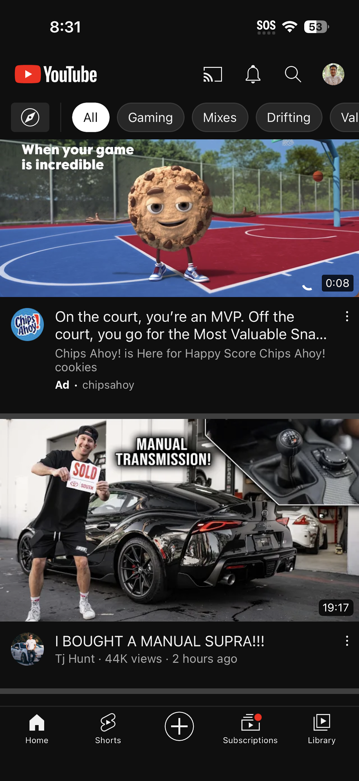

**Problems:**

* Better UI
* Secure content
* Spam users
* Video quality

**Navigation:**

* Down Arrow sign to minimize
* Full screen button
* Cross sign to cancel the played video

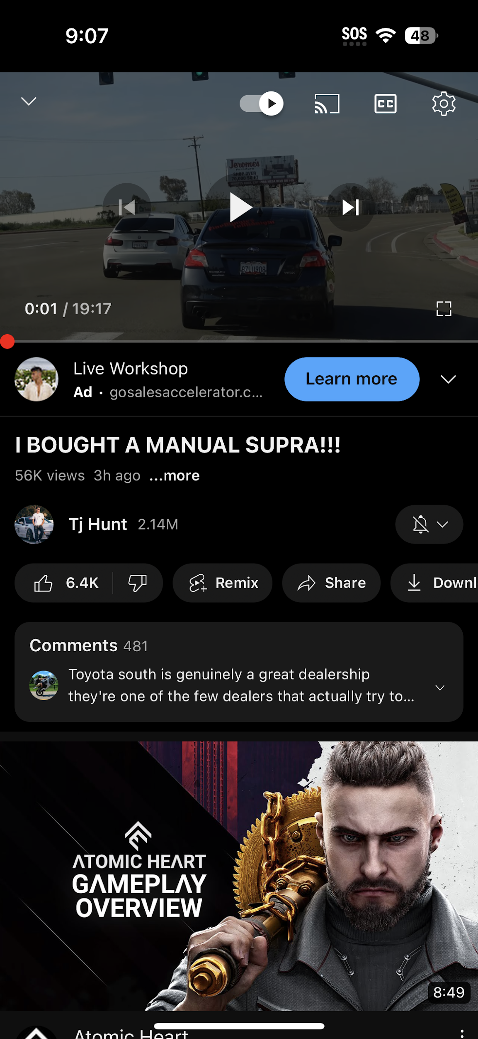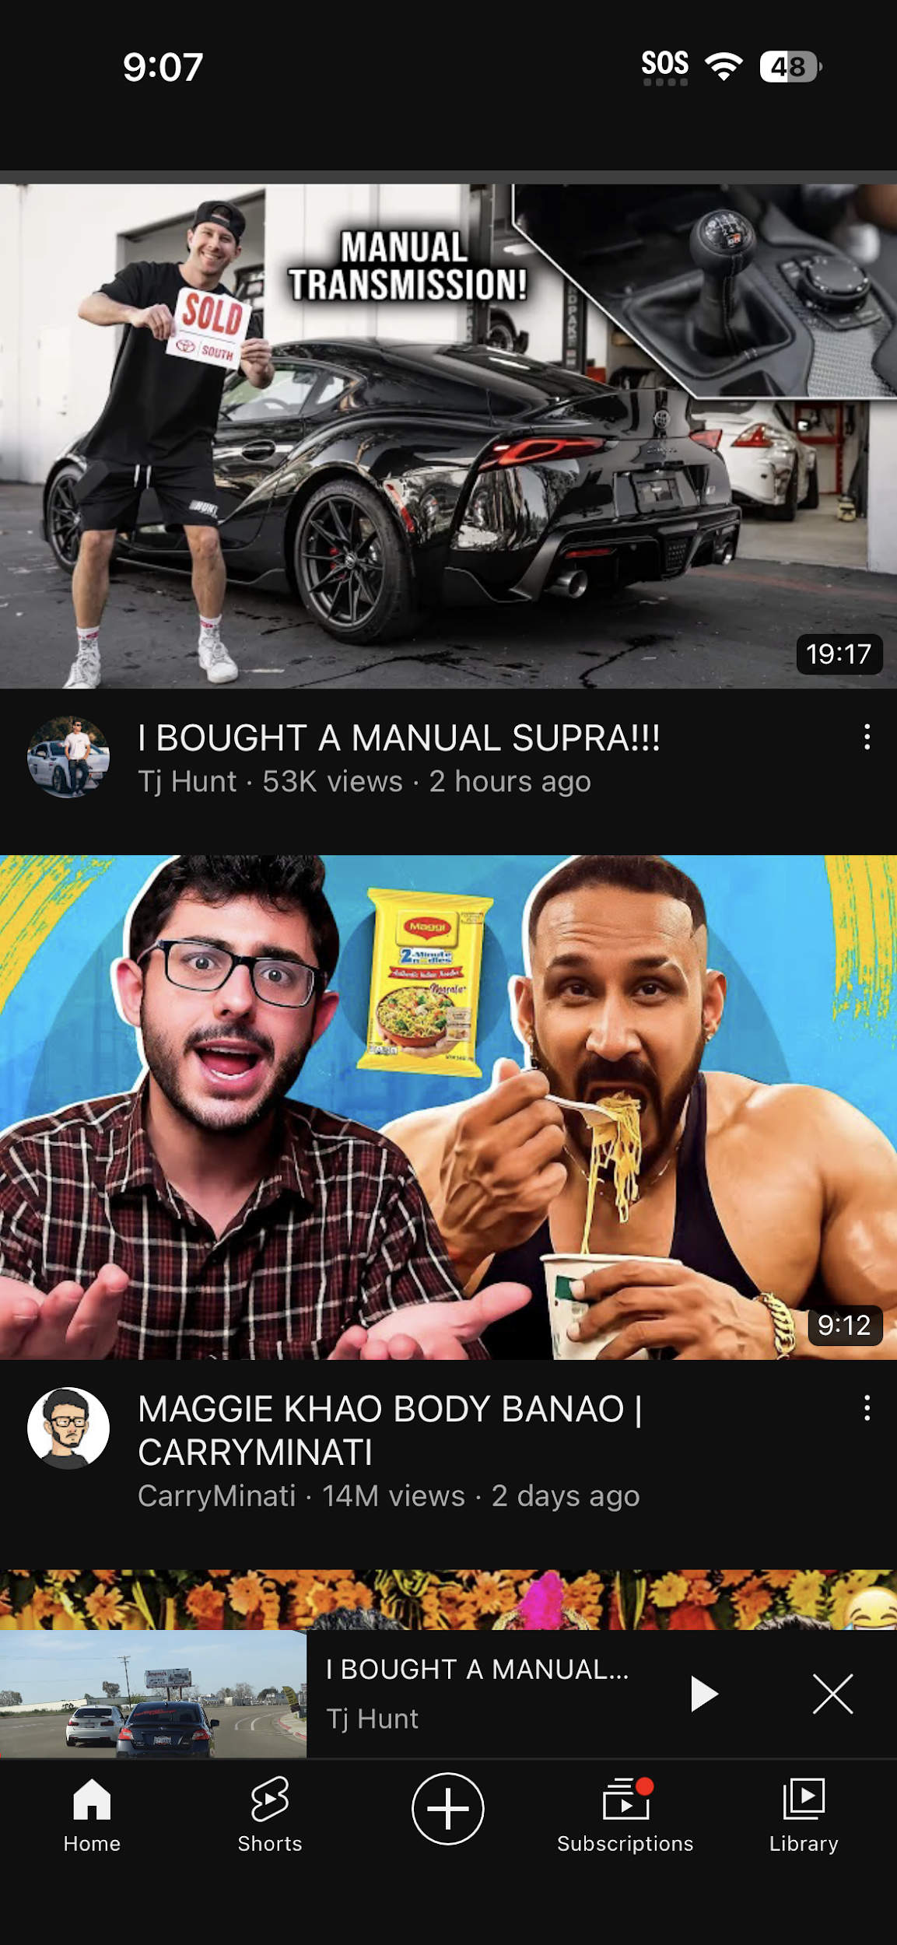

Does this app use navigation? If so, how is it used and is it effective, why/why not?

Ans: This app has some navigation like Down Arrow for minimizing the playing video, Square shape sign for full screen and Cross sign for cancel the video. All of the usages of the navigation buttons are effective.

**Notifications:**

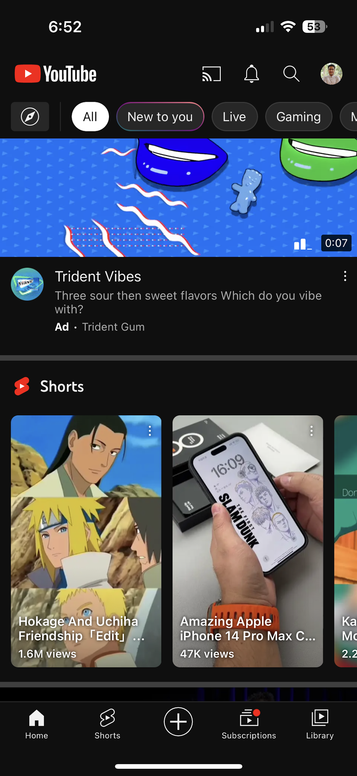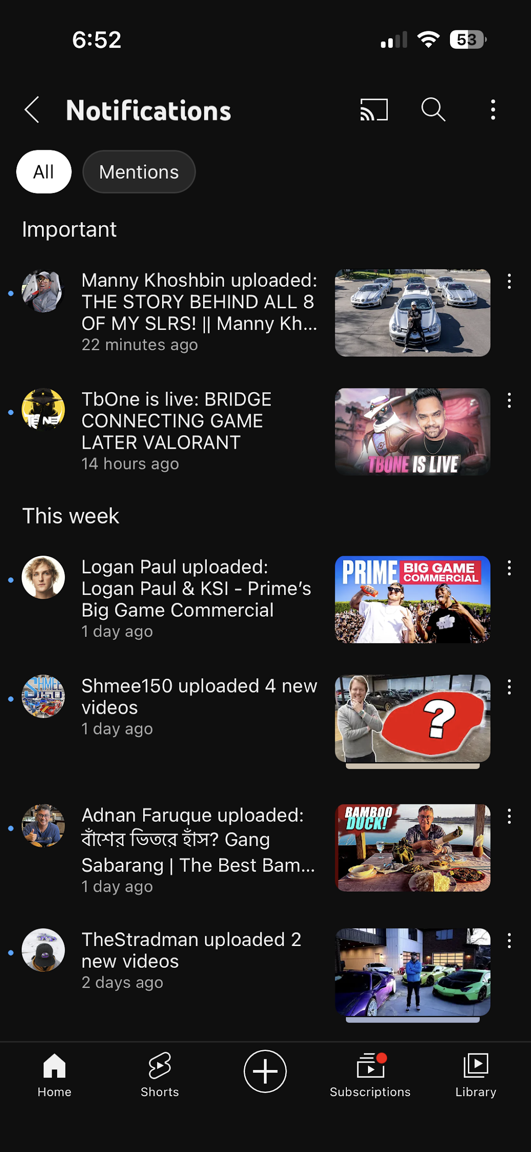

Does this app have a notification? If so, how is it used and is it effective, why/why not?

Ans: The App uses a bell icon for the notification and when we click on that we can see all of our notifications there. It is really useful for getting updates daily.

**Dialog:**

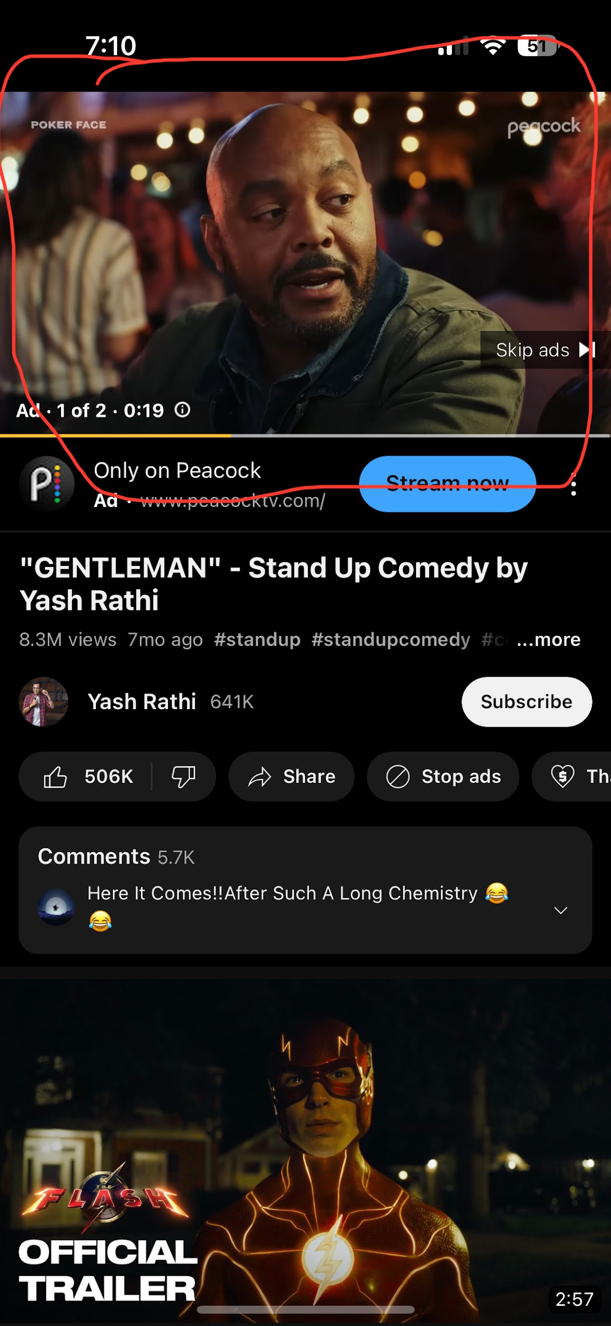

Does this app use Dialog? If so, how is it used and is it effective, why/why not?

Ans: So Youtube shows this type of advertisement and you can not skip it before 5 seconds. Sometimes it is useful but most of the time it is annoying for the users.

**Arrows:**

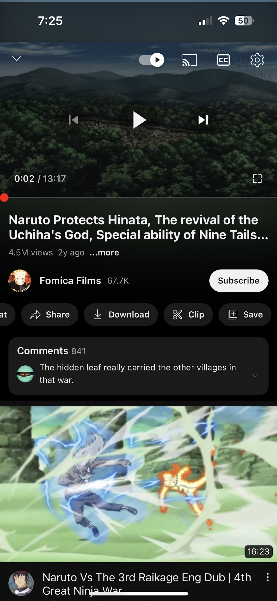

Does this app use arrows effectively, why/why not?

Ans: This app has arrows for maximizing and minimizing the description which is really necessary as it makes the interface look clean. Also a arrow is used to minimize to video which is playing.

**Orientation:**

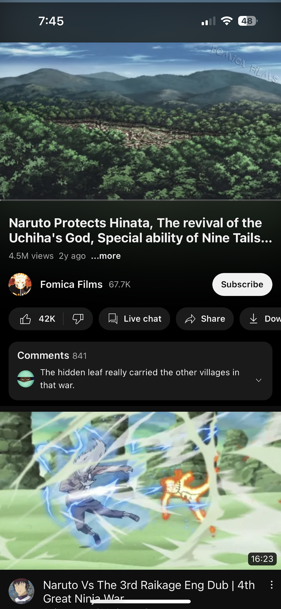

Does your chosen app use portrait, landscape or both?

Ans: This app uses both portrait and landscape for interface.

Does this app use orientation effectively, why/why not?

Ans: The app uses orientation effectively as you can use landscape only when you play a video.

**Sharing:**

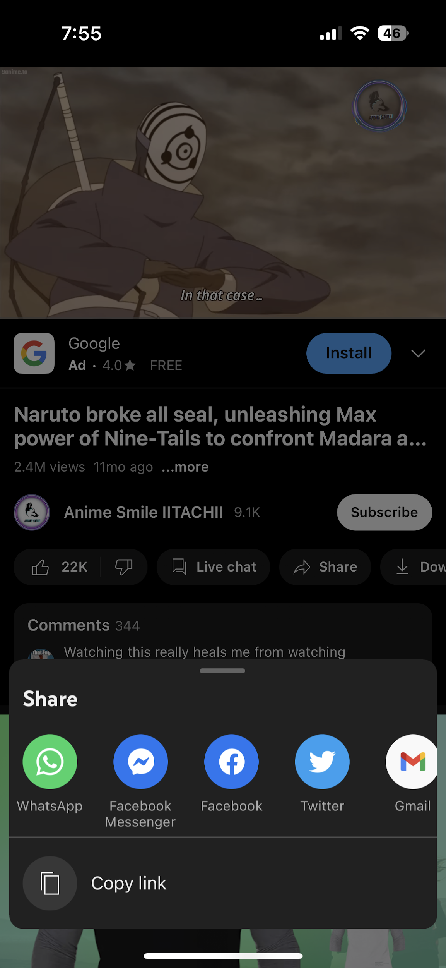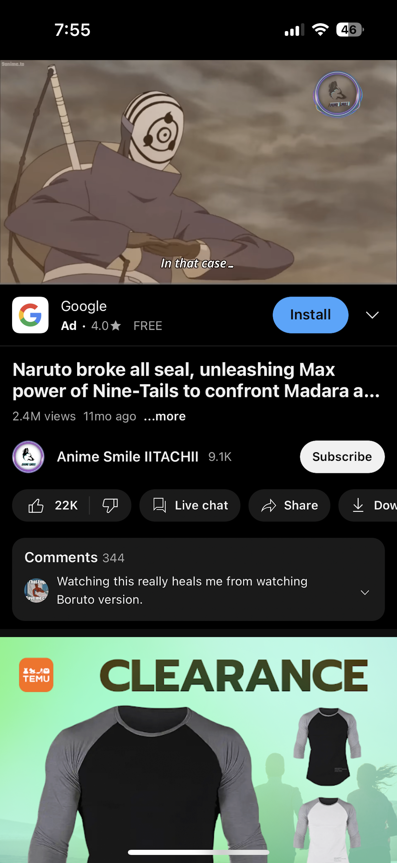

Does your chosen app have a sharing interaction?

Ans: Yes, the app has sharing interaction.

**Secondary Actions:**

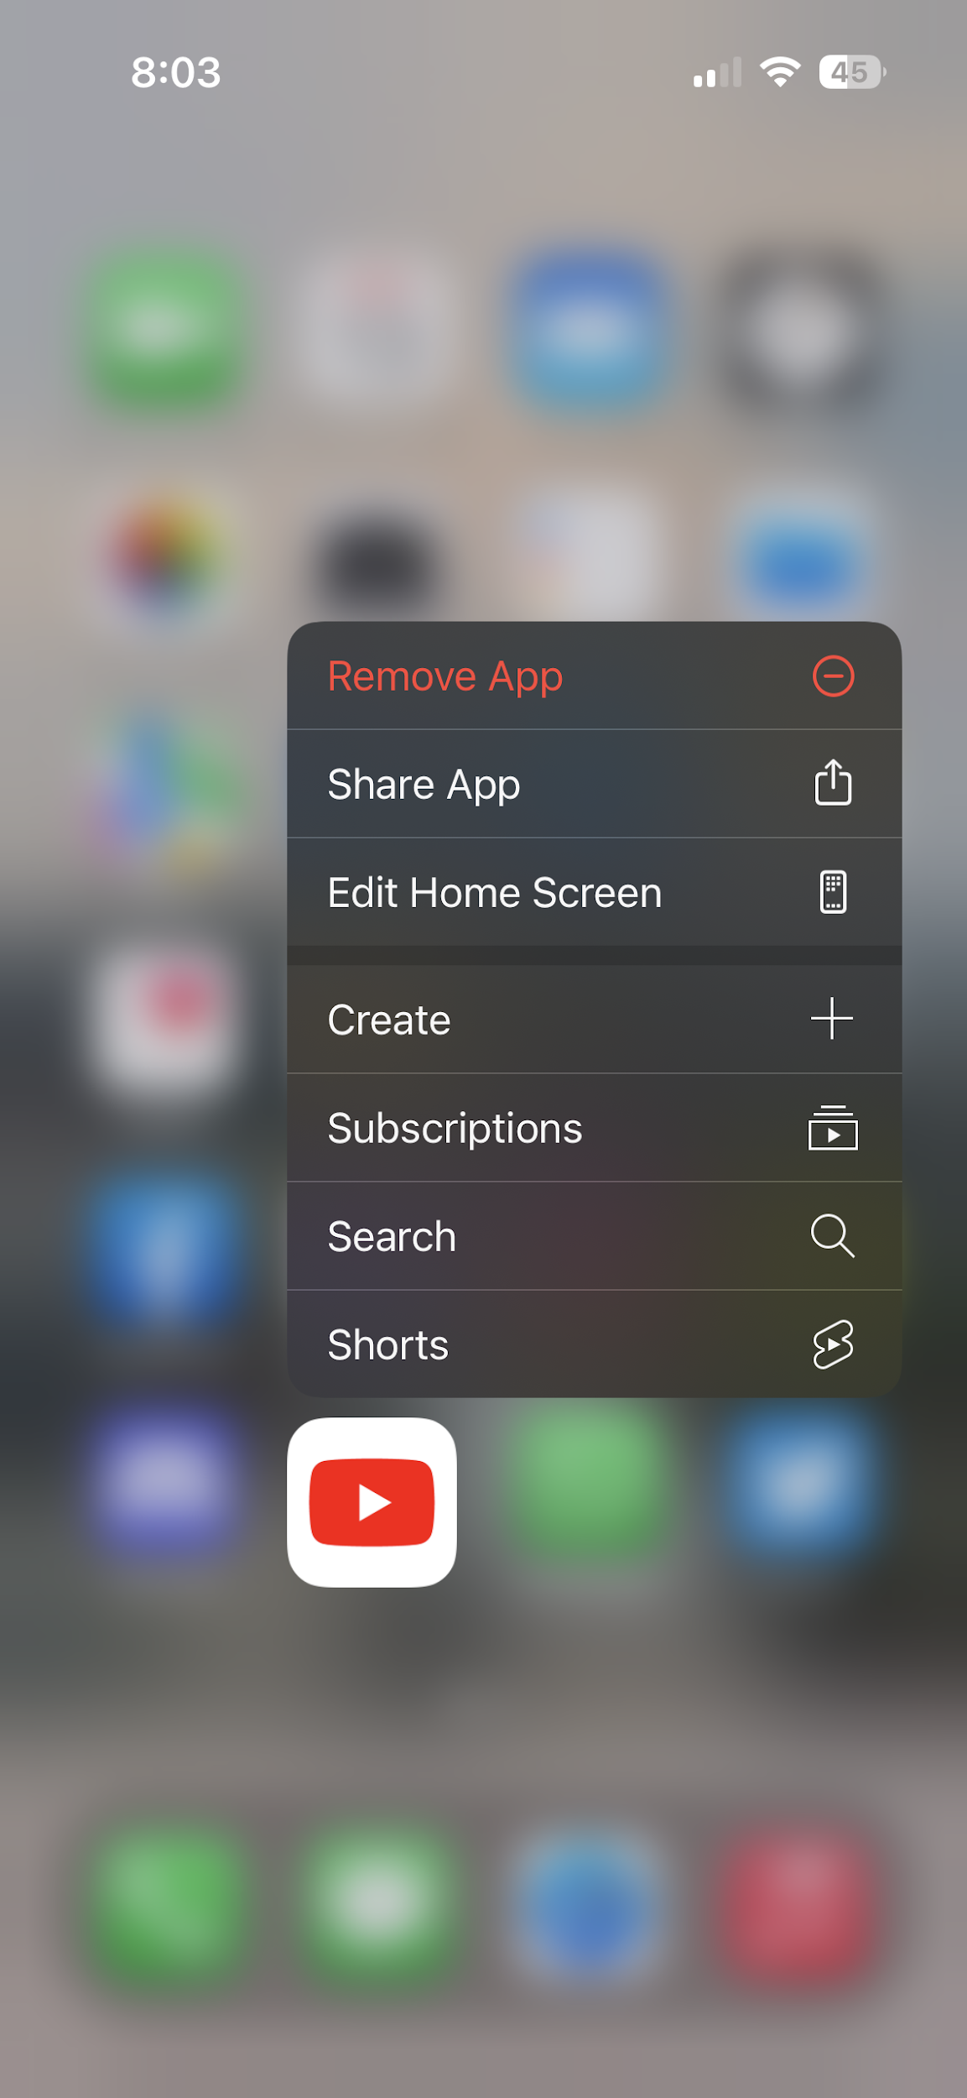

Does this app have secondary actions? If so, how are they accessed and are they effective, why/why not?

Ans: Yes, the app has some secondary actions which helps the users to access some things easily and effectively.

**Progressive Disclosure:**

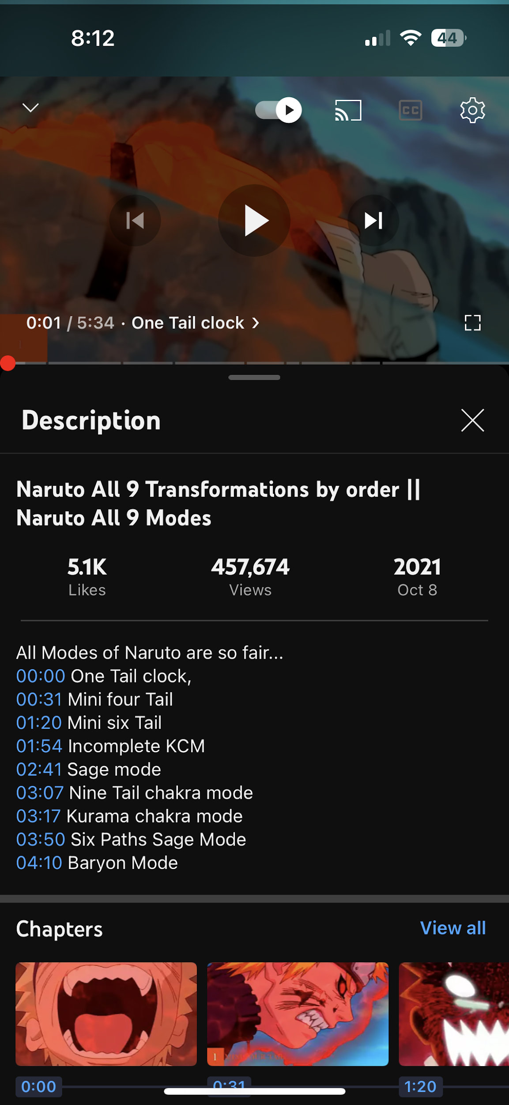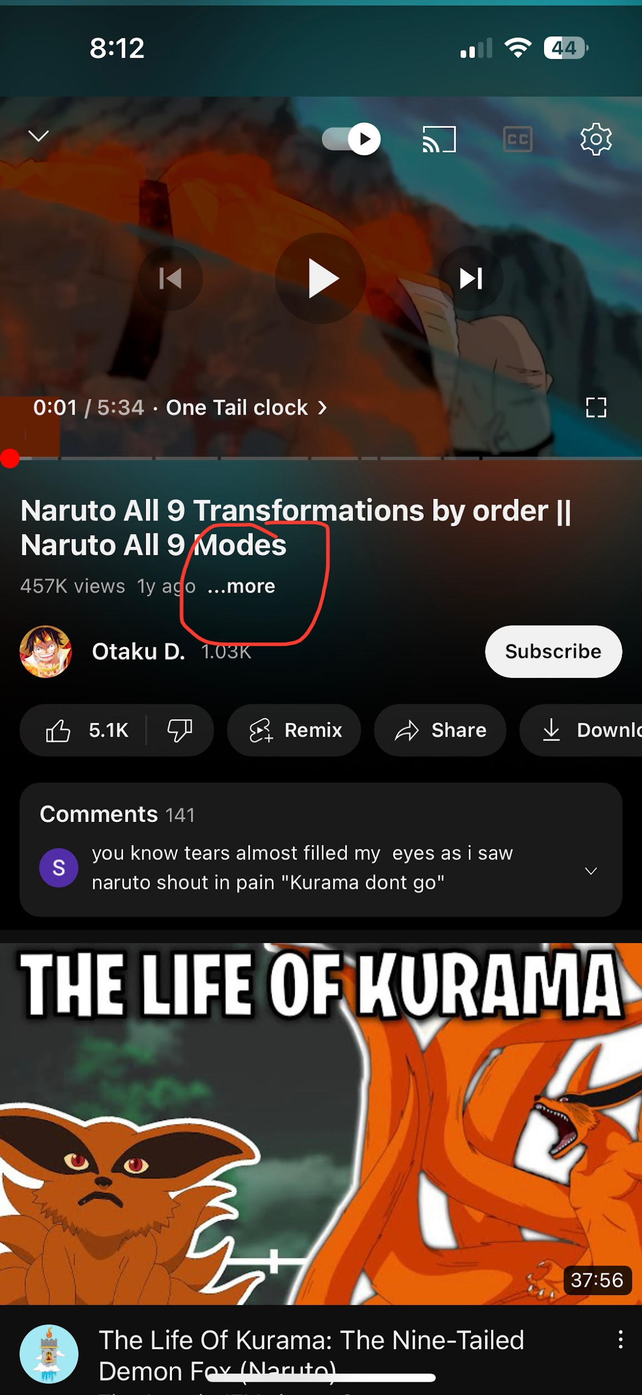

Does this app use progressive disclosure? If so, how is it used and is it effective, why/why not?

Ans: Yes, the app uses progressive disclosure for showing the video description which can be access by pressing the more button.

**Lazy Login:**

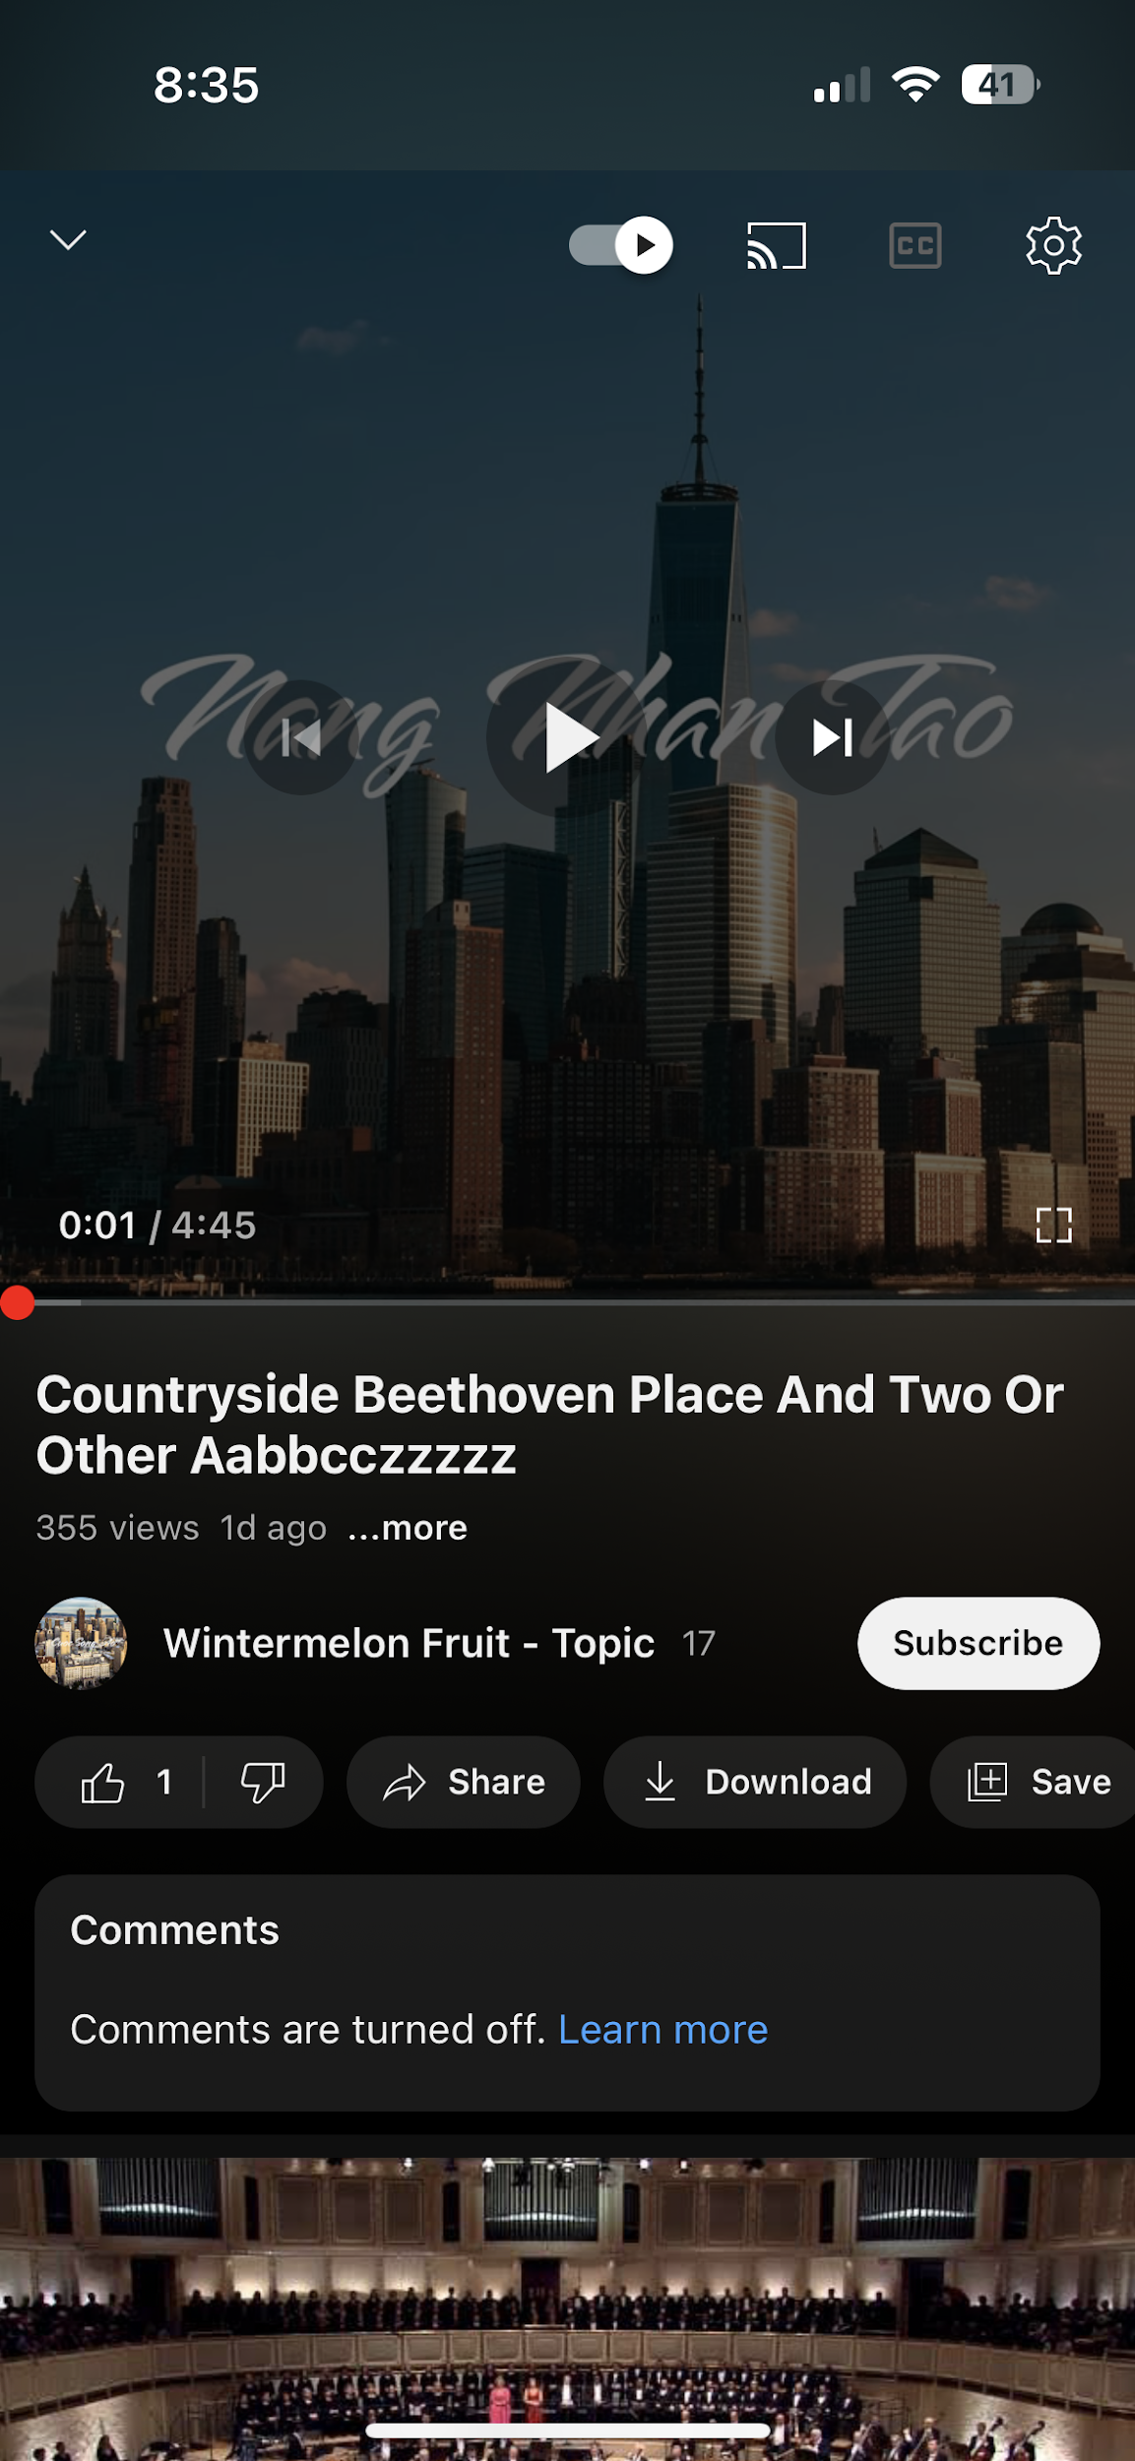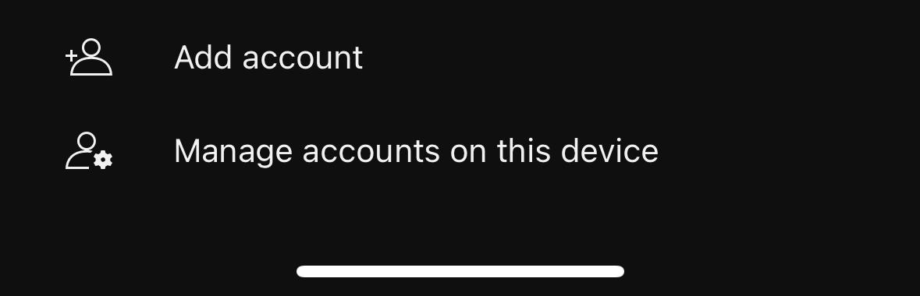

Does this app use lazy login? If so, how is it used and is it effective, why/why not?

Ans: Yes, this app use lazy login very effectively, you can watch or share any video without login but you can not like or comment without login.

**Swipe to Refresh:**

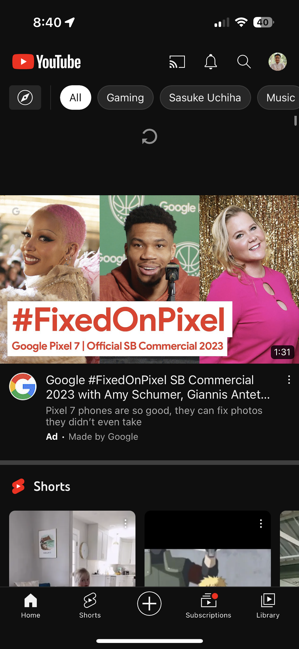

Does this app use swipe to refresh? If so, how is it used and is it effective, why/why not?

Ans: Yes, this app uses swipe to refresh, this is a very important feature for the app as you can easily refresh and have a new recent video list easily.

**Search Suggestion:**

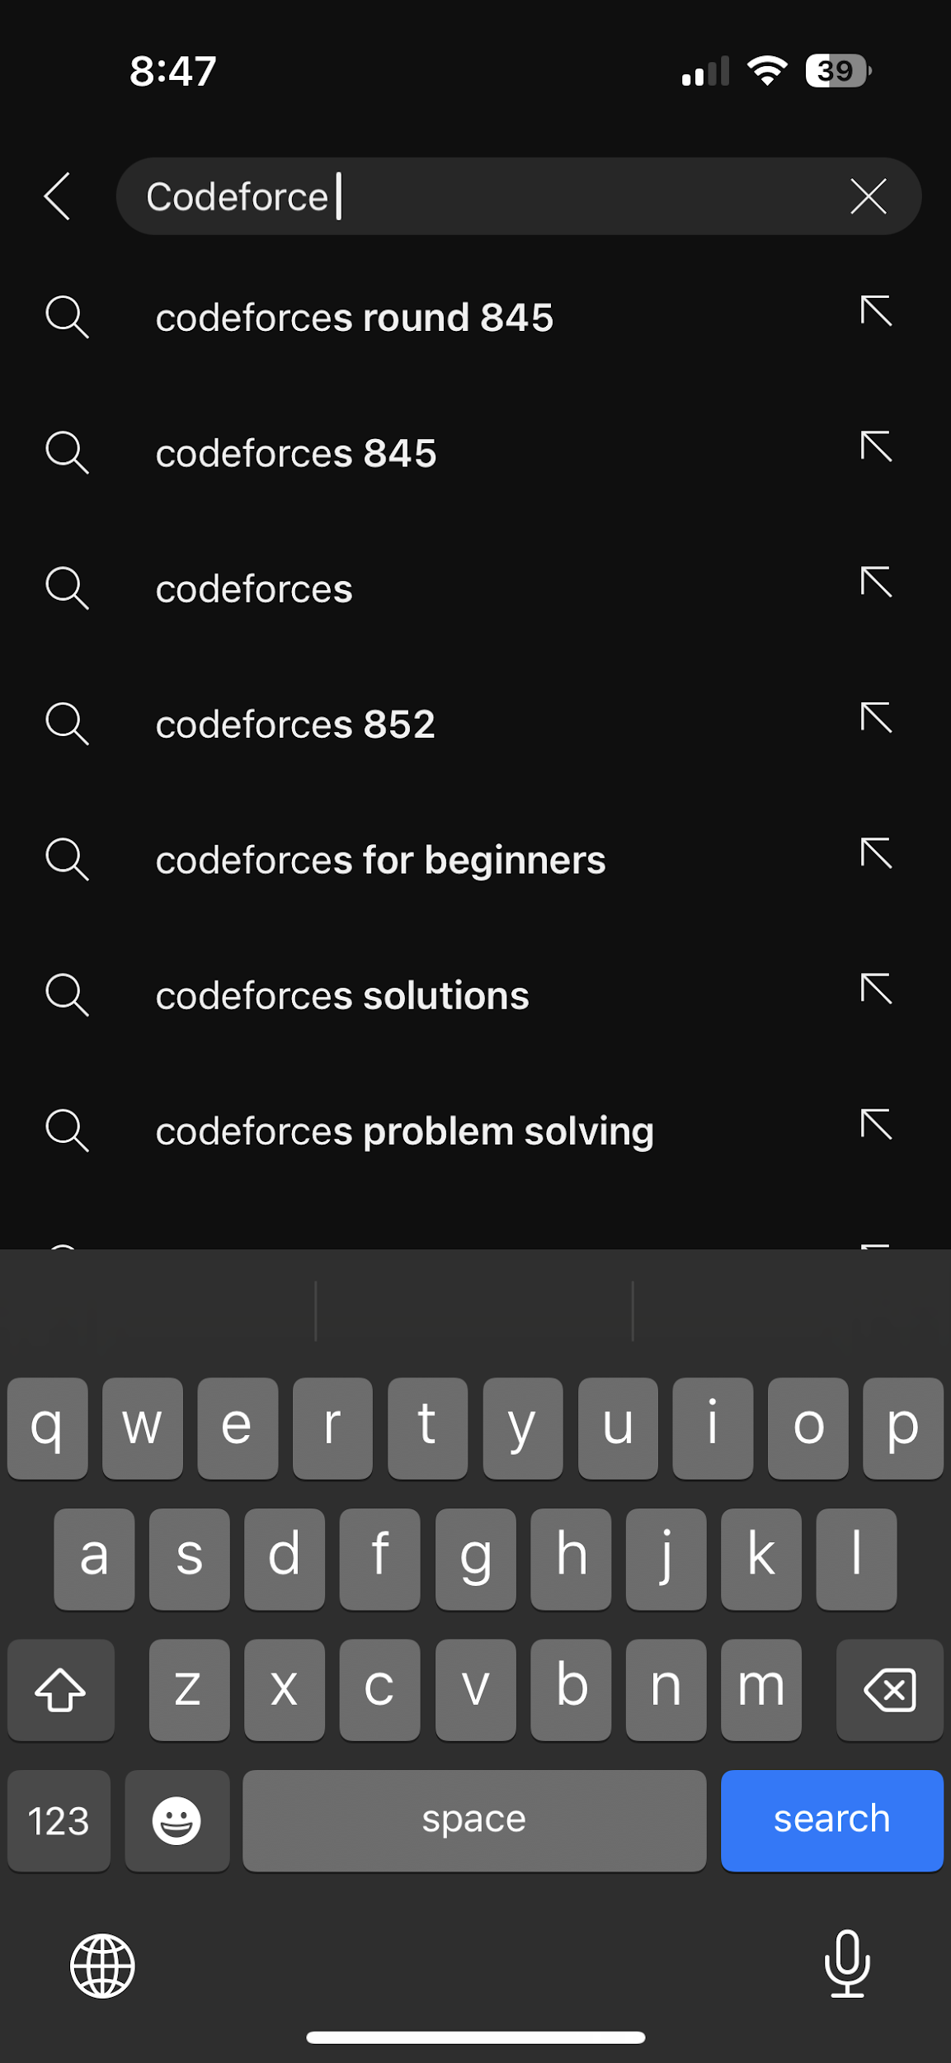

Does this app use search and search suggestions? If so, how is it used and is it effective, why/why not?

Ans: Yes, the app uses search and search suggestions and it is very effective and helpful for users as you can easily find what you are looking for.